THE EFFECTIVENESS OF THE LAST MAN STANDING GAME TO ENRICH STUDENTS’ VOCABULARY MASTERY

(A Case of the Eighth Graders of SMP Al-Fattah Semarang in the Academic Year of 2016/2017)

FINAL PROJECT

Presented as Partial Fulfillment of the Requirements to Obtain the (Sarjana Pendidikan) Degree in English Language Education
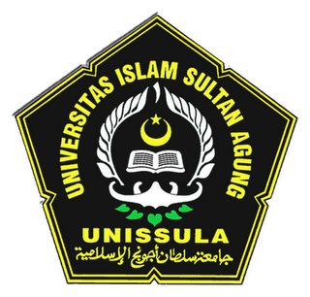

Siti Rohmah Hasanah
31801200424

ENGLISH EDUCATION DEPARTMENT

COLLEGE OF LANGUAGES

SULTAN AGUNG ISLAMIC UNIVERSITY

SEMARANG

2017
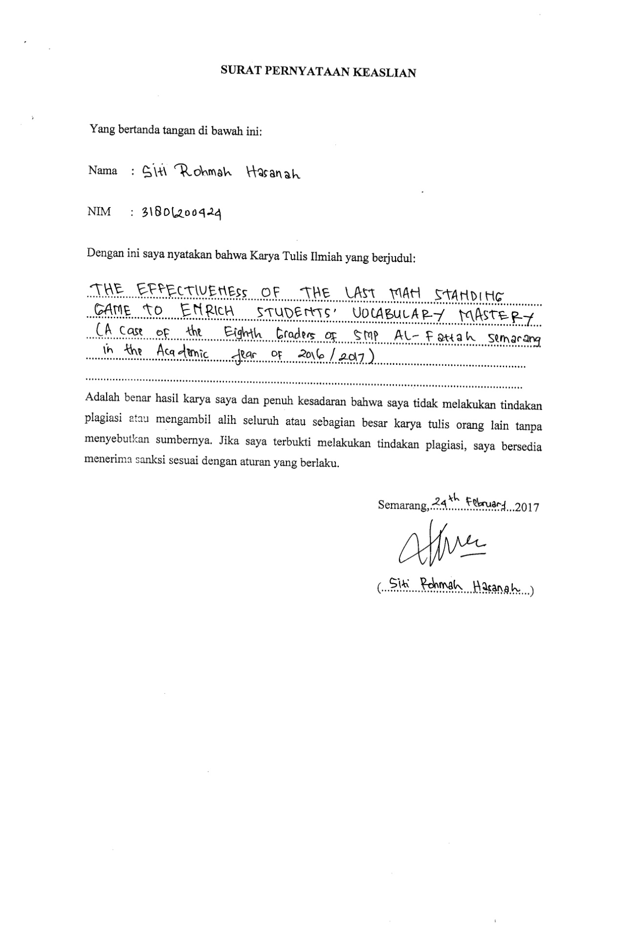
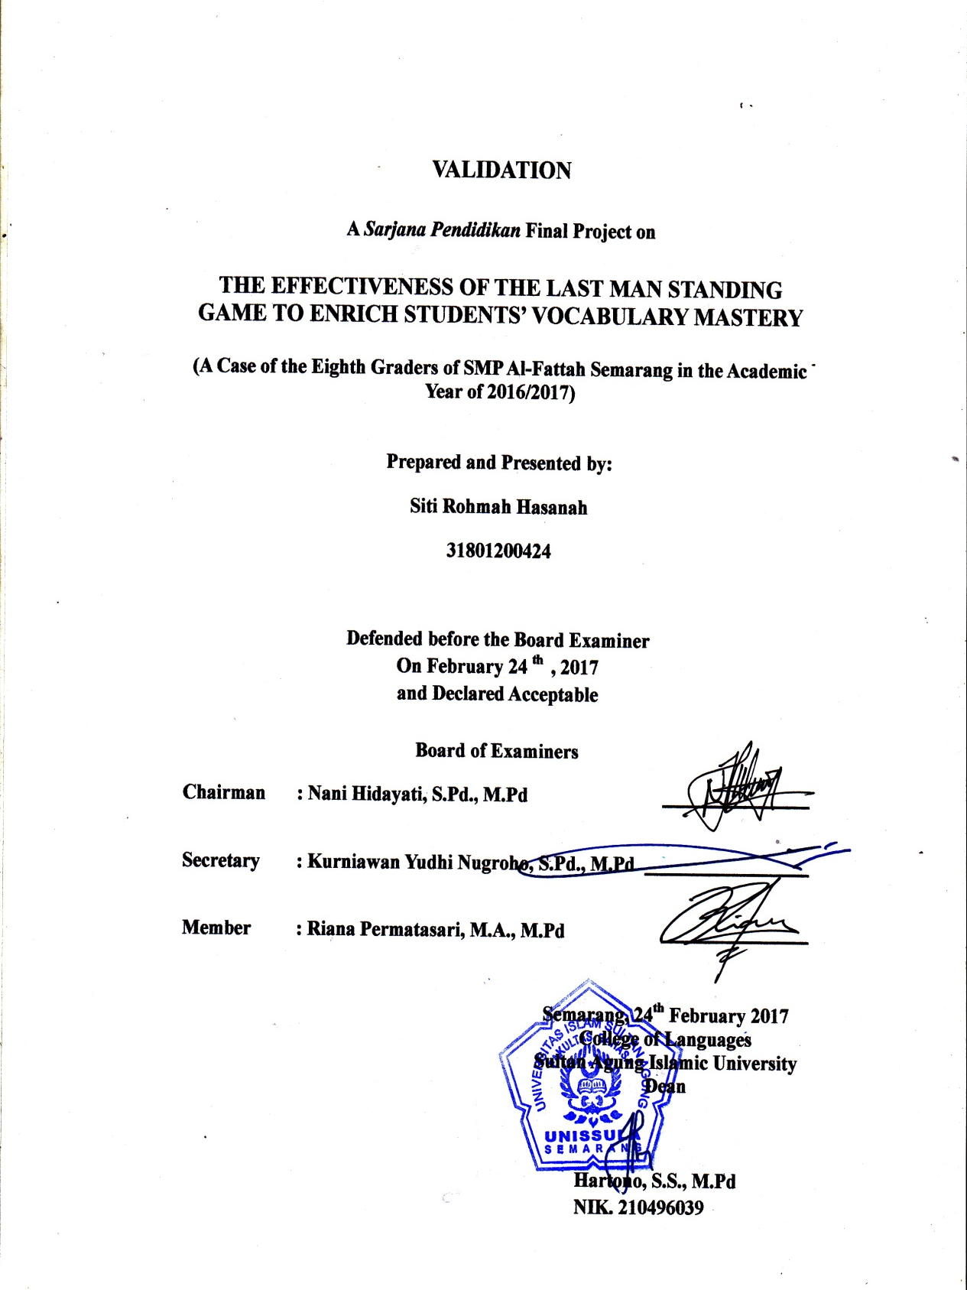
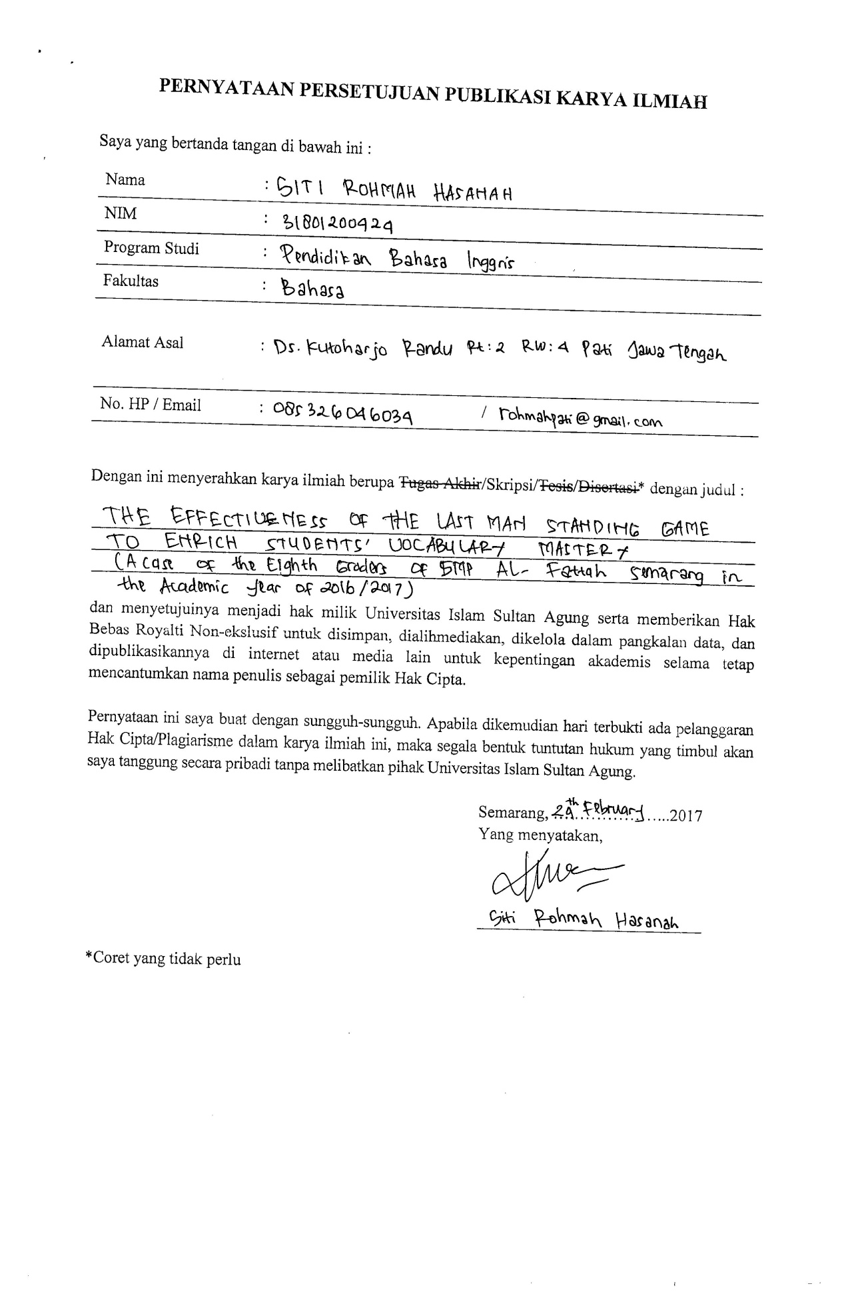
MOTTO AND DEDICATION
Motto

يَا أَيُّهَا الَّذِينَ آمَنُوا اسْتَعِينُوا بِالصَّبْرِ وَالصَّلَاةِ ۚ إِنَّ اللَّهَ مَعَ الصَّابِرِينَ
O you who have belived, seek help through patience and prayer.
Indeed, Allah is with the patient.
(QS. Al-Baqarah: 153)

Dedication
This final project is dedicated with affection, love and gratitude to:
- My beloved parents (Mr. Suwarno and Mrs. Jumini)
- My beloved sister ( Nur Afni Kurniawati)
- My beloved nieces (Lestariani and Nyutina Iklima Dewi)
- My English Department best friends, E1, E2 and E3 ’12 class.

ACKNOWLEDGEMENT
In the name of Allah SWT, the Merciful, the Gracious, the writer would like to convey my deepest gratitude to Allah. In this great chance, the writer would like to convey my deepest gratitude and appreciation to many people who contributed in completing and finishing this final project. The writer would like to express her sincere gratitude to:
- Anis Malik Thoha M.A Ph.D., as the Rector of College of Languages Sultan Agung Islamic University.
- Hartono, S.S., M.Pd., as the Dean of College of Languages Sultan Agung Islamic University.
- Didik Murwantono, S.S., M.Hum., as the Secretary of College of Languages Sultan Agung Islamic University.
- Kurniawan Yudhi Nugroho, S.Pd, M.Pd., as the head of Study Program College of Languages Sultan Agung Islamic University.
- Nani Hidayati, S.Pd, M.Pd., as my advisor who always gives the writer guidance and helps to finish the final Project.
- All of lecture and staff of the English Department, who have given lesson, knowledge, and support during my study.
- Suratman S.Kom., as the headmaster of SMP Al-Fattah Semarang and all teachers who had given the writer a chance to conduct the research there.
- Danis Juliastuti, S.Pd., as English teacher in SMP Al-Fattah Semarang for her help and cooperation during my study.
- My beloved family, my father Mr. Suwarno and mother Mrs. Jumini who always give their affection, support and prayers.
- My Sweatheart, Kiswanto S.H., who continuously gives his affection, support and always reminds me to finish this final project.
- My best friends, Dani Arifka, Farah Damayanti, Heny Rachmawati, Devy Aryani, Handira and Isnaini Roro for your cherish to keep supporting and reminding me during this study.
- My friends from E1, E2 and E3 class who always give the writer support and help me during the ups and down finishing this study.
- All people who cannot be mentioned one by one and who helped me during this study. May Allah always bless them all.
Finally, the writer realizes that this final project is still far for being perfect. However, the writer hopes that this final project will be useful for the reader.

Semarang, 8th February 2017

Siti Rohmah Hasanah
NIM: 31801200424

